**Gesture-Controlled Virtual Mouse: Effortless Computer Navigation**

**Group Members:**

|  |  |  |
| --- | --- | --- |
| **First name** | **Last Name** | **Student number** |
| Aravinda | Dharmalingam | C0861320 |
| Janakan | Sivapathasundaram | C0898225 |
| Keerthana | Amalanathan Valarmathi | C0895321 |
| Thirumalan | Sathananthan | C0902020 |

**Submission date:11th of August 2023**

hand_detector_module.py

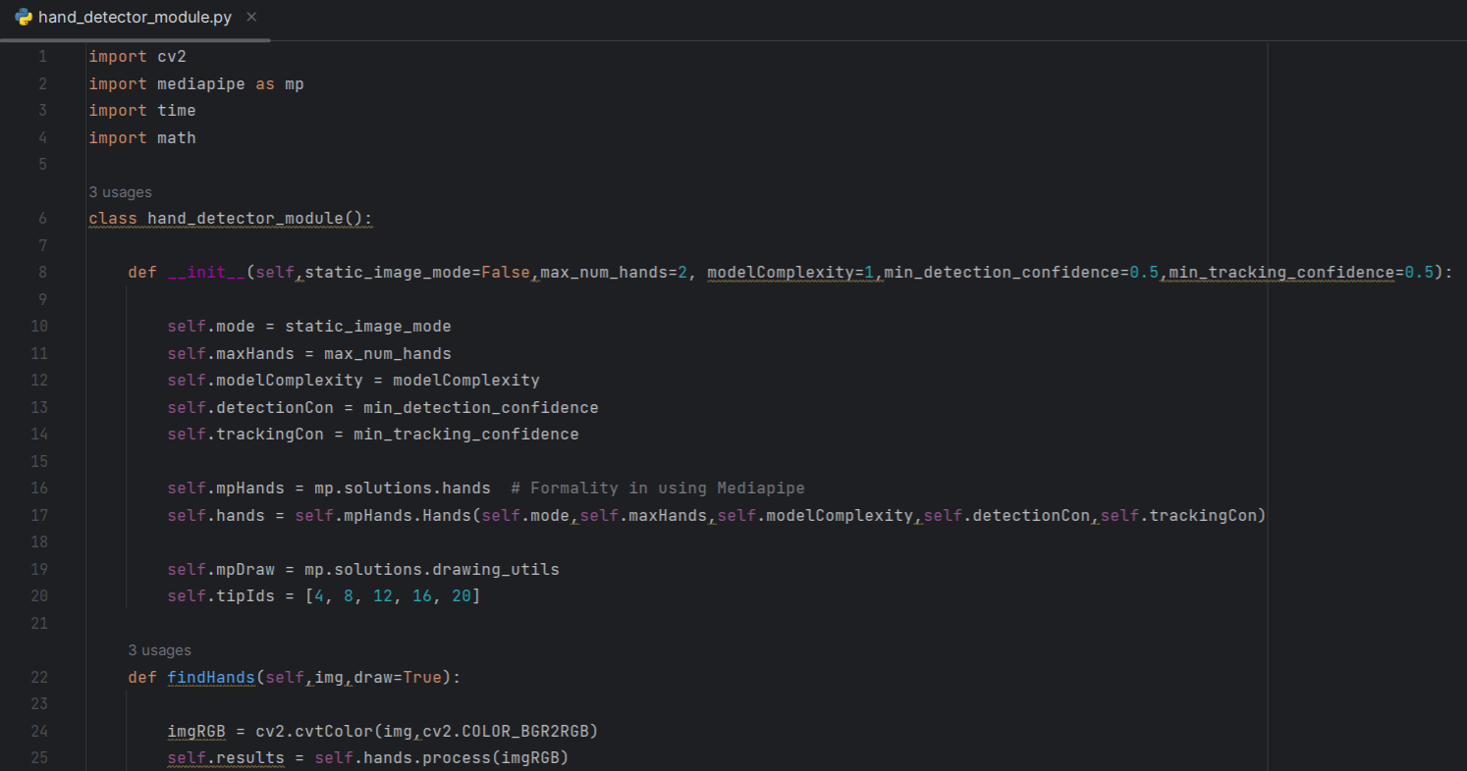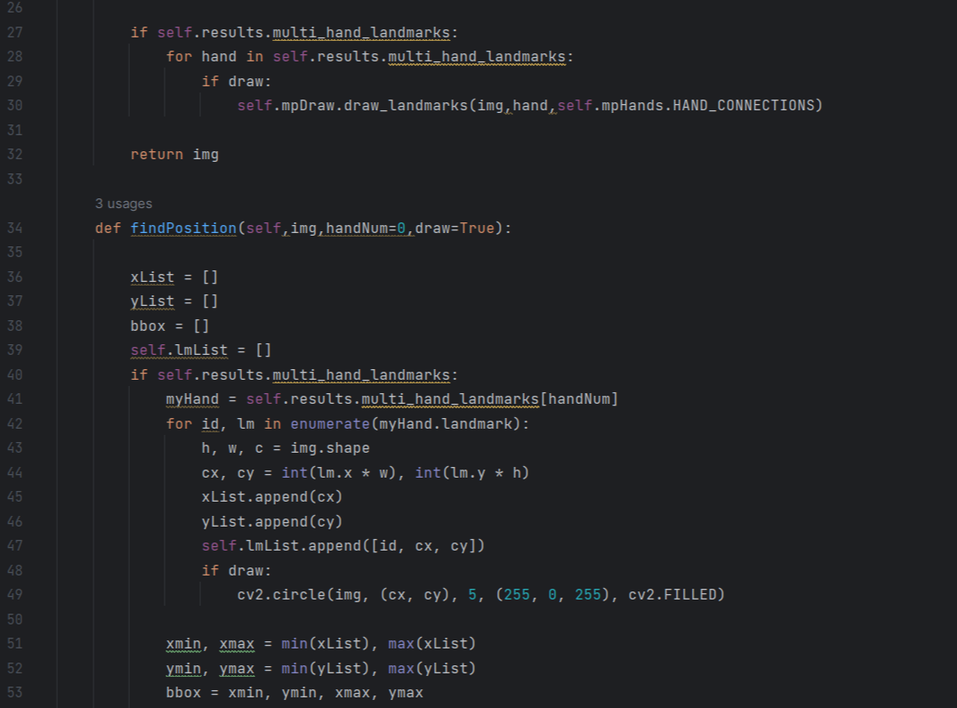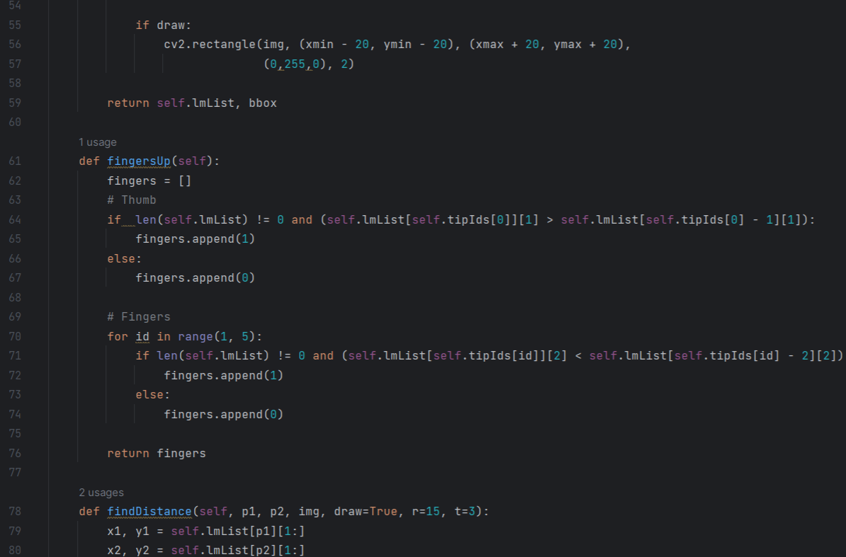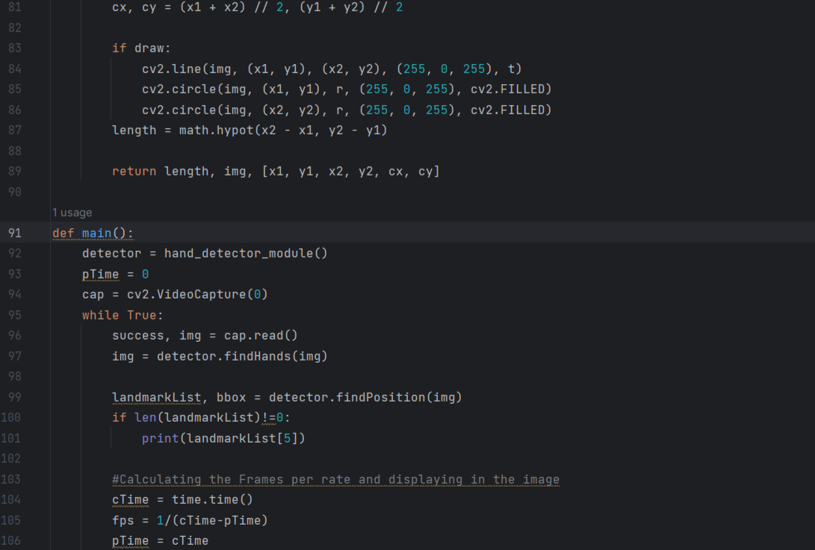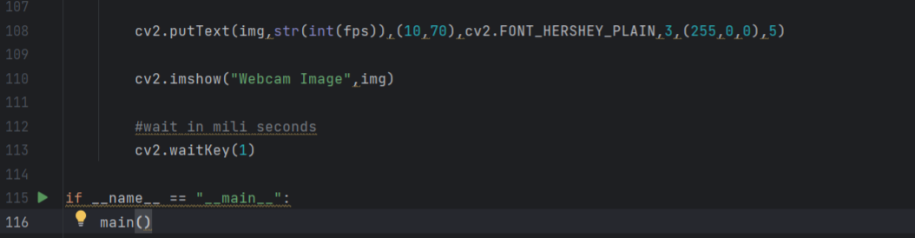

virtual_mouse_module.py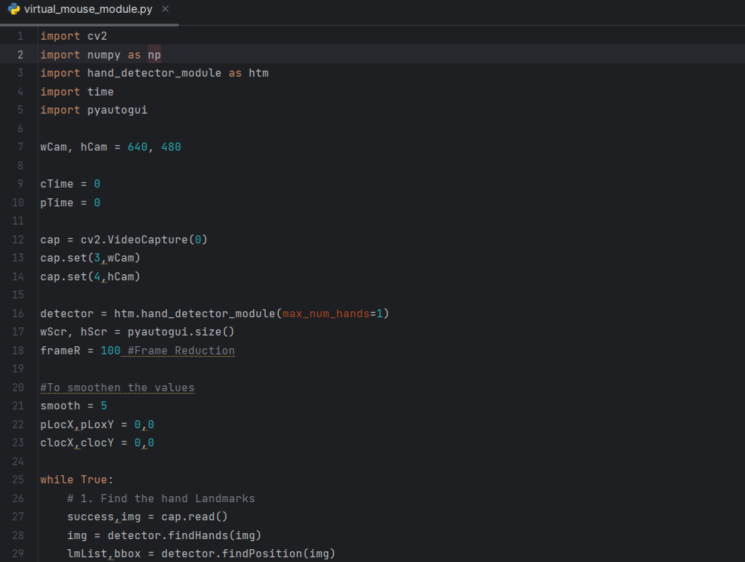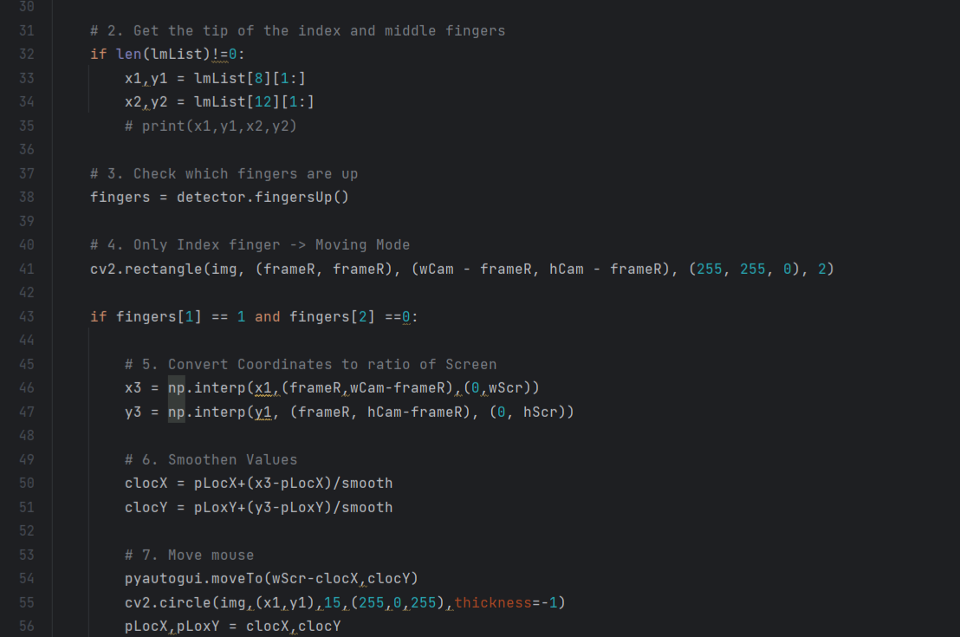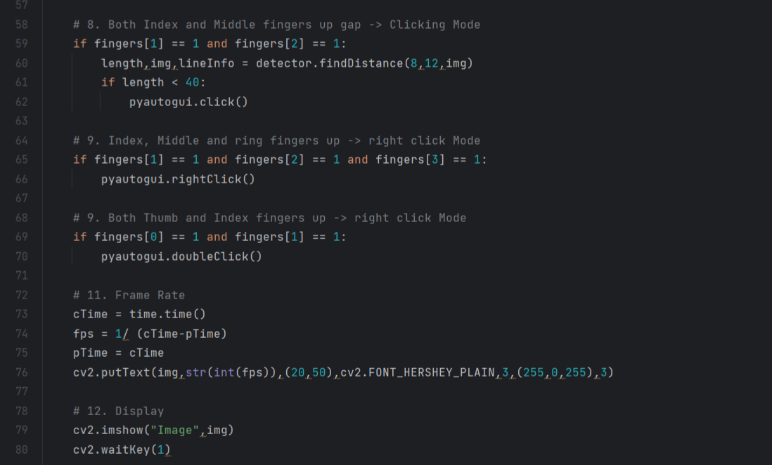

Outputs



Figure 1: Camera opening



Figure 2: Detecting hands.



Figure 3: Cursor movement using hands.



Figure 4: Cursor movement and hand detection.



Figure 5: Left Click.



Figure 6: Right Click.



Figure 7: Right click along with left click.



Figure 8: Double Click.



Figure 9: Double click along with left click (Double clicking the word and highlight the text).



Figure 10: Double click and right, left click (Performing cut operation by double clicking the word and right clicking and selecting the cut option)